(1A)

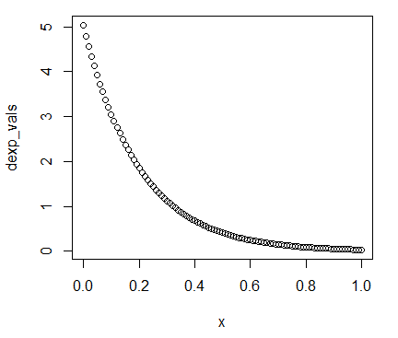

(1B)

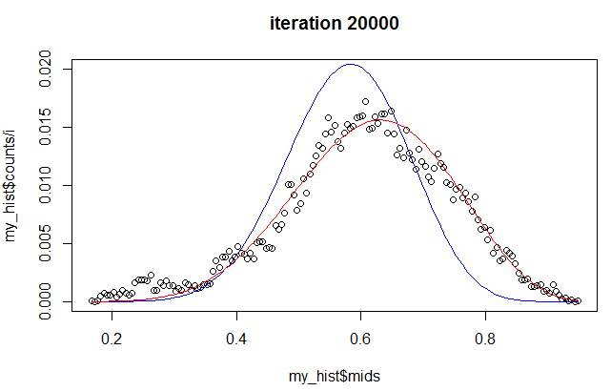

Blue line is the beta analytical solution, dots are the metropolis algorithm, and the red line is the grid algorithm.

(1C)

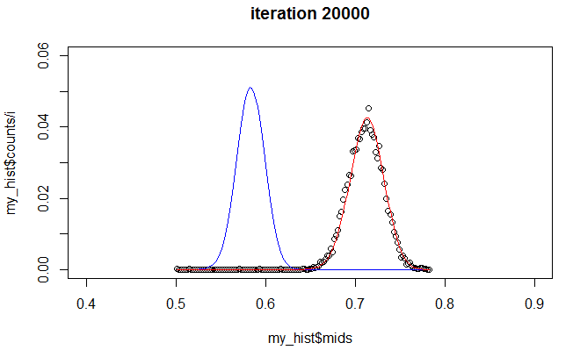

It appears that the grid and metropolis algorithm remain similar because they use an exponential prior. On the other hand, the beta distribution which doesn’t use the exponential prior is completely different and is similar to the previous curve (obviously more narrow due to the additional data added).